**Exercise 1: Mocking and Stubbing**

**Scenario:** You need to test a service that depends on an external API. Use Mockito to mock the external API and stub its methods.

**Solution:**

**Tools Used:** Java 8, JUnit 5, Mockito 3.12.4, Eclipse IDE, Maven for dependency management

**Steps Performed:**

1. Create a Maven project in Eclipse named mockito-demo
2. Add dependenciesin pom.xml
3. Create an external API interface

package com.example;

public interface WeatherApi {

String getWeather(String city);

}

package com.example;

public class WeatherService {

private WeatherApi weatherApi;

public WeatherService(WeatherApi weatherApi) {

this.weatherApi = weatherApi;

}

public String getWeatherMessage(String city) {

String weather = weatherApi.getWeather(city);

return "The weather in " + city + " is " + weather;

}

}

package com.example;

import static org.mockito.Mockito.*;

import org.junit.jupiter.api.Test;

import static org.junit.jupiter.api.Assertions.*;

public class WeatherServiceTest {

*@Test*

public void testGetWeatherMessage() {

WeatherApi mockApi = *mock*(WeatherApi.class);

*when*(mockApi.getWeather("Chennai")).thenReturn("Sunny");

WeatherService service = new WeatherService(mockApi);

String result = service.getWeatherMessage("Chennai");

*assertEquals*("The weather in Chennai is Sunny", result);

}

}

**Output:**

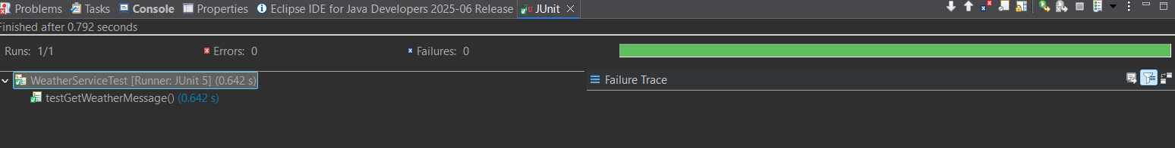

**Exercise 2: Verifying Interactions**

**Scenario:** You need to ensure that a method is called with specific arguments.

**Solution:**

**Tools Used:** Java 8, JUnit 5, Mockito 3.12.4, Eclipse IDE, Maven for dependency management

**Steps Performed:**

1. Created a Maven project and added the required dependencies (junit-jupiter and mockito-core).
2. Defined an external API interface named ExternalApi.
3. Created a service class named MyService that depends on ExternalApi.
4. Wrote a JUnit test to verify the interaction between the service and the API mock.

package New;

public interface ExternalApi {

void getData();

}

package New;

public class MyService {

private ExternalApi externalApi;

public MyService(ExternalApi externalApi) {

this.externalApi = externalApi;

}

public void fetchData() {

externalApi.getData();

}

}

package New;

import static org.mockito.Mockito.*;

import org.junit.jupiter.api.Test;

import org.mockito.Mockito;

public class MyServiceTest {

*@Test*

public void testVerifyInteraction() {

ExternalApi mockApi = Mockito.*mock*(ExternalApi.class);

MyService service = new MyService(mockApi);

service.fetchData();

*verify*(mockApi).getData();

}

}

**Output:**

